##### EXPERIMENT NO:-02

**Aim:** **Mapping ER/EER to Relational schema model**.

**Theory:**

After designing the ER diagram of system, we need to convert it to Relational models which can directly be implemented by any RDBMS like Oracle, MySQL etc. There are rules to convert ER Diagram to Relational Model.

* **Rule-1: For Strong Entity Set With Simple Attributes and composite attribute:**
  + Each strong entity set becomes a Table.
  + Each simple, single, null attribute becomes a column of table.
  + Composite attributes are represented by components.
  + The key attribute of the entity set becomes primary key of the table.

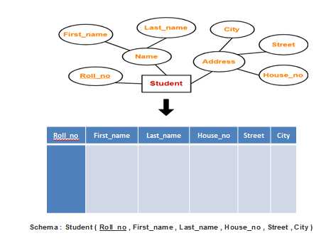

* **Rule-2 : Strong Entity Set With Multi Valued Attributes**
  + Multi-valued attributes are represented by a separate table
  + One table will contain all the simple attributes with the primary key.

Other table will contain the primary key and all the multi valued attributes.

* **Example:**

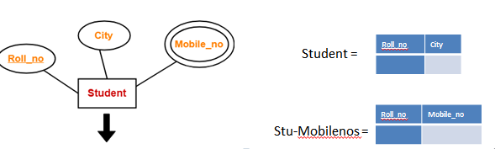

* **Rule 3-: For Binary Relationship With Cardinality Ratio 1:1**
  + The primary key of the either of the participants can become a foreign key in other..
  + Example :

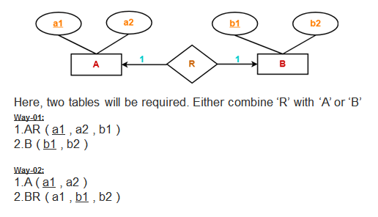

Here, two tables will be required. Either combine ‘R’ with ‘A’ or ‘B’

* **Rule 4-: For Binary Relationship With Cardinality Ratio 1:n**
  1. The primary key of the entity on the “1” side of the relationship set becomes a foreign key in the relation on the “N” side.
  2. Example :

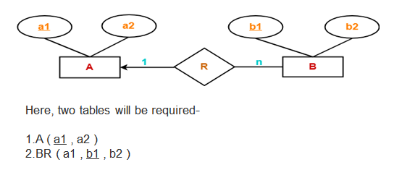

* **Rule 5-: For Binary Relationship With Cardinality Ratio m:1**
  + The primary key of the entity on the “1” side of the relationship set becomes a foreign key in the relation on the “N” side.
  + Example :

**Case Study:**

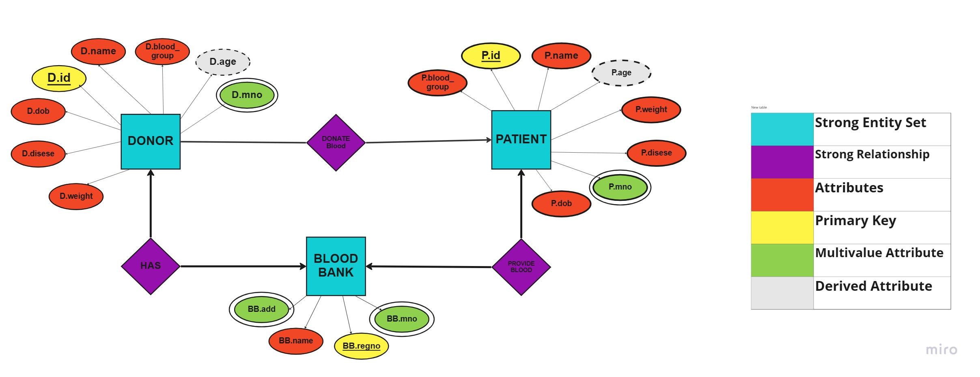

**Input & Output:**

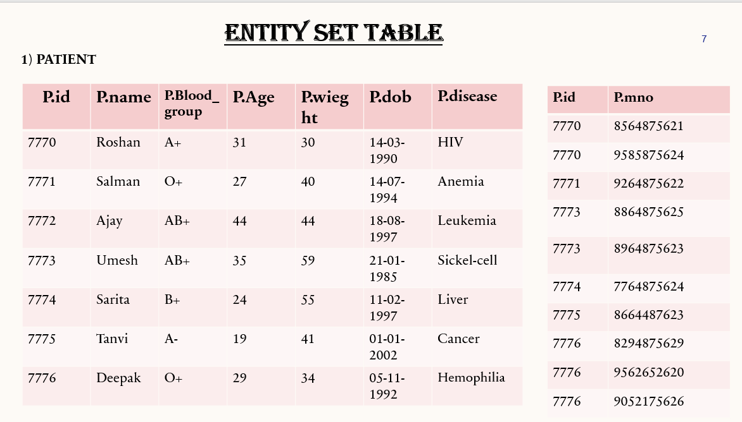

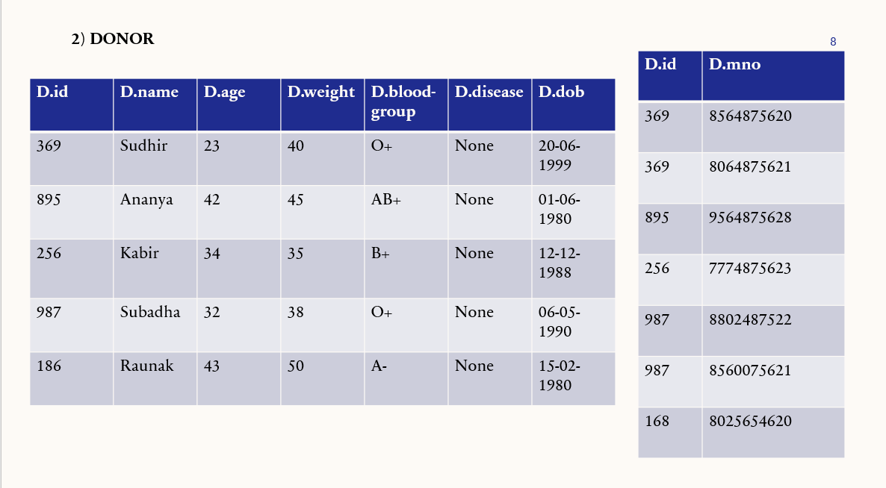

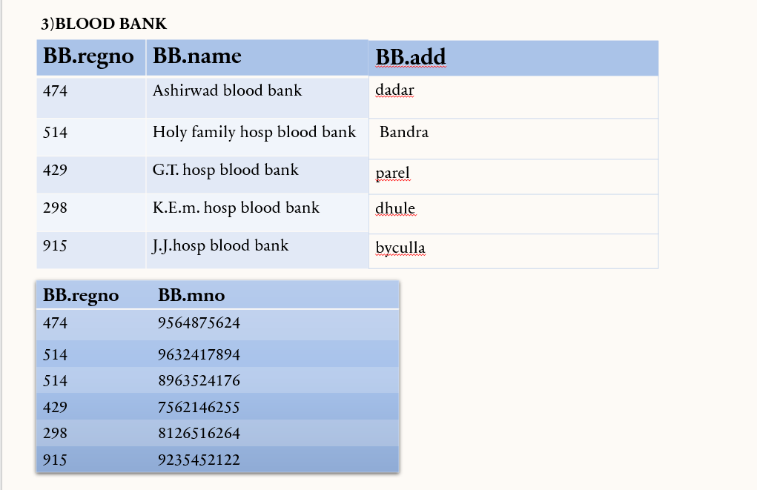

**1) Patient ---------- Donate----------- Donor (One to Many)**

**2) Donor ---------- Has -----------Blood Bank ( Many to Many )**

**3) Blood Bank ---------- Provide Blood ---------- Patient ( Many to Many )**

**Conclusion:**

|  |  |  |  |  |  |
| --- | --- | --- | --- | --- | --- |
| **R1** | **R2** | **R3** | **R4** | **Total** | **Sign with Date** |
| **(3)** | **(5)** | **(4)** | **(3)** | **(15)** |  |
|  |  |  |  |  |